Lld

Tata Play Fiber Self-Onboarding Middleware Backend

Low-Level Design (LLD) Document
This document provides the low-level design details, API specs, database schemas, and technical implementation components for the Tata Play Fiber Onboarding Middleware Backend.
---

1. Database Schema Design (PostgreSQL DDL Reference)
-- Central Master Table
CREATE TABLE onboarding_master (
prospect_id UUID PRIMARY KEY DEFAULT gen_random_uuid(),
rmn VARCHAR(15) NOT NULL,
email VARCHAR(255) NOT NULL,
customer_name VARCHAR(100) NOT NULL,
current_step VARCHAR(50) NOT NULL, -- Enum values (e.g. STEP_1_FEASIBILITY)
status VARCHAR(30) NOT NULL, -- IN_PROGRESS, COMPLETED, NRFS, FAILED
customer_id VARCHAR(50), -- Synced from HOBS
account_id VARCHAR(50), -- Synced from HOBS
created_at TIMESTAMP WITHOUT TIME ZONE DEFAULT CURRENT_TIMESTAMP,
updated_at TIMESTAMP WITHOUT TIME ZONE DEFAULT CURRENT_TIMESTAMP
);
-- Transition Audit Log
CREATE TABLE onboarding_transition_log (
id BIGSERIAL PRIMARY KEY,
prospect_id UUID REFERENCES onboarding_master(prospect_id),
from_step VARCHAR(50) NOT NULL,
to_step VARCHAR(50) NOT NULL,
transition_time TIMESTAMP WITHOUT TIME ZONE DEFAULT CURRENT_TIMESTAMP,
payload_snapshot JSONB
);
-- Step 1 Table: Lead Details
CREATE TABLE lead_details (
prospect_id UUID PRIMARY KEY REFERENCES onboarding_master(prospect_id),
rmn VARCHAR(15) NOT NULL,
customer_name VARCHAR(100) NOT NULL,
email VARCHAR(255) NOT NULL,
full_address TEXT NOT NULL,
latitude NUMERIC(9, 6),
longitude NUMERIC(9, 6),
is_feasible BOOLEAN DEFAULT FALSE,
build_type VARCHAR(100),
address_status VARCHAR(20) NOT NULL, -- FEASIBLE, NRFS
status VARCHAR(30) NOT NULL,
created_at TIMESTAMP WITHOUT TIME ZONE DEFAULT CURRENT_TIMESTAMP
);
-- Step 2 & 3 Table: OTP Verification
CREATE TABLE otp_verification (
prospect_id UUID PRIMARY KEY REFERENCES onboarding_master(prospect_id),
rmn VARCHAR(15) NOT NULL,
email VARCHAR(255) NOT NULL,
otp_hash VARCHAR(255) NOT NULL,
expiry_time TIMESTAMP WITHOUT TIME ZONE NOT NULL,
attempts_count INT DEFAULT 0,
is_verified BOOLEAN DEFAULT FALSE,
status VARCHAR(30) NOT NULL, -- OTP_SENT, OTP_VERIFIED, EXPIRED, FAILED
verified_at TIMESTAMP WITHOUT TIME ZONE
);
-- Step 4 Table: Document Collection
CREATE TABLE document_collection (
prospect_id UUID PRIMARY KEY REFERENCES onboarding_master(prospect_id),
poi_type VARCHAR(50) NOT NULL,
poi_document_number VARCHAR(100) NOT NULL,
poi_file_path VARCHAR(500) NOT NULL,
poa_type VARCHAR(50) NOT NULL,
poa_document_number VARCHAR(100) NOT NULL,
poa_file_path VARCHAR(500) NOT NULL,
live_photo_file_path VARCHAR(500) NOT NULL,
declaration_form_file_path VARCHAR(500) NOT NULL,
trust_validation_status VARCHAR(50) NOT NULL, -- SUCCESS, FAILED
trust_validation_remarks TEXT,
is_migrated BOOLEAN DEFAULT FALSE,
status VARCHAR(30) NOT NULL, -- PENDING, UPLOADED, VERIFIED, FAILED, MIGRATED
created_at TIMESTAMP WITHOUT TIME ZONE DEFAULT CURRENT_TIMESTAMP
);
-- Step 5 Table: Profile Building
CREATE TABLE profile_building (
prospect_id UUID PRIMARY KEY REFERENCES onboarding_master(prospect_id),
gst_number VARCHAR(15),
company_name VARCHAR(150),
gst_validation_status VARCHAR(30), -- SUCCESS, FAILED, N/A
additional_profile_data JSONB,
status VARCHAR(30) NOT NULL, -- PENDING, GST_VERIFIED, GST_FAILED, SUBMITTED
updated_at TIMESTAMP WITHOUT TIME ZONE DEFAULT CURRENT_TIMESTAMP
);
-- Step 7 & 8 Table: Plan Selection
CREATE TABLE plan_selection (
prospect_id UUID PRIMARY KEY REFERENCES onboarding_master(prospect_id),
package_id VARCHAR(50) NOT NULL,
package_name VARCHAR(150) NOT NULL,
base_price NUMERIC(10, 2) NOT NULL,
applied_offers JSONB,
total_discount NUMERIC(10, 2) DEFAULT 0.00,
total_tax NUMERIC(10, 2) DEFAULT 0.00,
final_payable_amount NUMERIC(10, 2) NOT NULL,
status VARCHAR(30) NOT NULL, -- PENDING, SELECTED, OVERRIDDEN
updated_at TIMESTAMP WITHOUT TIME ZONE DEFAULT CURRENT_TIMESTAMP
);
-- Step 9 Table: Payment Details
CREATE TABLE payment_details (
prospect_id UUID PRIMARY KEY REFERENCES onboarding_master(prospect_id),
customer_id VARCHAR(50),
account_id VARCHAR(50),
payment_link VARCHAR(1000),
link_expiry TIMESTAMP WITHOUT TIME ZONE,
payment_status VARCHAR(30) NOT NULL, -- PENDING, PAID, EXPIRED
hobs_sync_status VARCHAR(30) NOT NULL, -- SUCCESS, PENDING, FAILED
six_d_sync_status VARCHAR(30) NOT NULL, -- SUCCESS, PENDING, FAILED
generation_attempts INT DEFAULT 0,
status VARCHAR(30) NOT NULL, -- PENDING, INITIATED, SUCCESS, EXPIRED, FAILED
created_at TIMESTAMP WITHOUT TIME ZONE DEFAULT CURRENT_TIMESTAMP,
updated_at TIMESTAMP WITHOUT TIME ZONE DEFAULT CURRENT_TIMESTAMP
);
-- Step 11 Table: Consent Details
CREATE TABLE consent_details (
prospect_id UUID PRIMARY KEY REFERENCES onboarding_master(prospect_id),
whatsapp_message_sid VARCHAR(100),
consent_status VARCHAR(30) NOT NULL, -- PENDING, APPROVED, REJECTED
status VARCHAR(30) NOT NULL,
consent_received_at TIMESTAMP WITHOUT TIME ZONE
);
-- Step 12 Table: CAF Details
CREATE TABLE caf_details (
prospect_id UUID PRIMARY KEY REFERENCES onboarding_master(prospect_id),
caf_pdf_url VARCHAR(500) NOT NULL,
status VARCHAR(30) NOT NULL, -- PENDING, GENERATED, FAILED
generated_at TIMESTAMP WITHOUT TIME ZONE DEFAULT CURRENT_TIMESTAMP
);
-- Step 13 Table: EKYC Details
CREATE TABLE ekyc_details (
prospect_id UUID PRIMARY KEY REFERENCES onboarding_master(prospect_id),
hobs_ticket_id VARCHAR(50) NOT NULL,
ekyc_status VARCHAR(50) NOT NULL,
status VARCHAR(30) NOT NULL, -- TICKET_CREATED, COMPLETED, FAILED
created_at TIMESTAMP WITHOUT TIME ZONE DEFAULT CURRENT_TIMESTAMP
);
---

2. API Endpoints & Payload Contracts
All API requests and responses utilize JSON payloads, structured with standard envelopes.

Step 1: Feasibility Check (`POST /api/v1/onboarding/feasibility`)
- **Request**:
{
"rmn": "9876543210",
"customerName": "Rohan Sharma",
"email": "rohan.sharma@example.com",
"address": {
"building": "Tower B, Flat 402, Sunshine Heights",
"street": "Main Road",
"city": "Mumbai",
"pincode": "400001",
"latitude": 18.9218,
"longitude": 72.8347
}
}
- **Response (Feasible - HTTP 201 Created)**:
{
"status": "SUCCESS",
"data": {
"prospectId": "c869bfbd-54b2-4d1a-be10-85f20658fa6c",
"feasible": true,
"buildType": "High-Rise Building",
"nextStep": "STEP_2_OTP_SENT"
}
}
- **Response (Not Feasible - HTTP 422 Unprocessable Content)**:
{
"status": "ERROR",
"error": {
"code": "NRFS_ERROR",
"message": "Fiber installation is currently not feasible at this location. Lead has been captured for future follow-up."
},
"data": {
"prospectId": "c869bfbd-54b2-4d1a-be10-85f20658fa6c",
"feasible": false
}
}

Step 2: Send OTP (`POST /api/v1/onboarding/otp/send`)
- **Request**:
{
"prospectId": "c869bfbd-54b2-4d1a-be10-85f20658fa6c"
}
- **Response (HTTP 200 OK)**:
{
"status": "SUCCESS",
"data": {
"message": "OTP has been successfully sent to registered mobile number and email."
}
}

Step 3: Validate OTP & State Recovery (`POST /api/v1/onboarding/otp/validate`)
- **Request**:
{
"prospectId": "c869bfbd-54b2-4d1a-be10-85f20658fa6c",
"otp": "482019"
}
- **Response (New Onboarding - HTTP 200 OK)**:
{
"status": "SUCCESS",
"data": {
"onboardingStatus": "NEW",
"redirectToStep": "STEP_4_DOCS_COLLECTED",
"savedData": null
}
}
- **Response (Resumed Onboarding - HTTP 200 OK)**:
{
"status": "SUCCESS",
"data": {
"onboardingStatus": "RESUME",
"redirectToStep": "STEP_8_AMOUNT_CALCULATED",
"savedData": {
"customerName": "Rohan Sharma",
"rmn": "9876543210",
"email": "rohan.sharma@example.com",
"address": "Tower B, Flat 402, Sunshine Heights, Mumbai - 400001",
"selectedPlan": {
"packageId": "PLAN_FIBER_150M",
"packageName": "150 Mbps Unlimited Plan",
"price": 799.0
}
}
}
}

Step 4: Document Collection (`POST /api/v1/onboarding/{prospectId}/documents`)
- **Content-Type**: `multipart/form-data`
- **Form Parameters**:
- `poiType`: "AADHAAR"
- `poiDocumentNumber`: "1234-5678-9012"
- `poiFile`: (Binary)
- `poaType`: "AADHAAR"
- `poaDocumentNumber`: "1234-5678-9012"
- `poaFile`: (Binary)
- `livePhoto`: (Binary)
- **Response (HTTP 200 OK)**:
{
"status": "SUCCESS",
"data": {
"poiStatus": "VERIFIED",
"poaStatus": "VERIFIED",
"faceMatchPercentage": 98.4,
"declarationFormUrl": "https://tataplayazure.blob.core.windows.net/leads/prospect_c869bfbd/declaration.pdf"
}
}

Step 5: Profile Building & GST Validation (`POST /api/v1/onboarding/{prospectId}/profile`)
- **Request**:
{
"gstNumber": "27AAAAA0000A1Z5",
"companyName": "Sharma Enterprises",
"additionalDetails": {
"alternateContact": "9876543211",
"billingPreferences": "PAPERLESS"
}
}
- **Response (HTTP 200 OK)**:
{
"status": "SUCCESS",
"data": {
"gstValidated": true,
"gstDetails": {
"registrationStatus": "ACTIVE",
"legalName": "Sharma Enterprises Private Limited"
}
}
}

Step 6: Plans & Offers Consolidation (`GET /api/v1/onboarding/{prospectId}/plans`)
- **Response (HTTP 200 OK)**:
{
"status": "SUCCESS",
"data": {
"plans": [
{
"packageId": "PLAN_FIBER_100M",
"packageName": "100 Mbps Unlimited",
"speed": "100 Mbps",
"basePrice": 699.0
},
{
"packageId": "PLAN_FIBER_150M",
"packageName": "150 Mbps Unlimited",
"speed": "150 Mbps",
"basePrice": 799.0
}
],
"applicableOffers": [
{
"couponCode": "FIBERFIRST",
"discountType": "PERCENTAGE",
"value": 10.0,
"description": "10% off on first monthly subscription"
}
]
}
}

Step 7: Plan Selection (`POST /api/v1/onboarding/{prospectId}/plan-select`)
- **Request**:
{
"packageId": "PLAN_FIBER_150M",
"couponCode": "FIBERFIRST"
}
- **Response (HTTP 200 OK)**:
{
"status": "SUCCESS",
"data": {
"prospectId": "c869bfbd-54b2-4d1a-be10-85f20658fa6c",
"selectedPlanId": "PLAN_FIBER_150M",
"couponApplied": "FIBERFIRST"
}
}

Step 8: Calculate Amount (`GET /api/v1/onboarding/{prospectId}/calculate-amount`)
- **Response (HTTP 200 OK)**:
{
"status": "SUCCESS",
"data": {
"basePrice": 799.00,
"discountApplied": 79.90,
"taxableValue": 719.10,
"cgst": 64.72,
"sgst": 64.72,
"totalPayableAmount": 848.54
}
}

Step 9: Payment Link Generation (`POST /api/v1/onboarding/{prospectId}/payment-link`)
- **Response (HTTP 202 Accepted)**:
{
"status": "ACCEPTED",
"data": {
"customerId": "CUST90812903",
"accountId": "ACC87239841",
"syncStatus": "PENDING",
"message": "HOBS accounts created. Dispatching payment link asynchronously upon billing sync confirmation."
}
}

Step 10: Document Migration (`POST /api/v1/onboarding/{prospectId}/migrate-docs`)
- **Response (HTTP 200 OK)**:
{
"status": "SUCCESS",
"data": {
"customerId": "CUST90812903",
"migratedFilesCount": 4,
"destinationPath": "/customers/customer_CUST90812903/"
}
}

Step 11: WhatsApp Consent (`POST /api/v1/onboarding/{prospectId}/consent/trigger`)
- **Response (HTTP 200 OK)**:
{
"status": "SUCCESS",
"data": {
"consentStatus": "PENDING_CUSTOMER_ACTION",
"message": "Consent request dispatched to WhatsApp number."
}
}

Step 12: CAF Generation (`POST /api/v1/onboarding/{prospectId}/caf`)
- **Response (HTTP 201 Created)**:
{
"status": "SUCCESS",
"data": {
"cafUrl": "https://tataplayazure.blob.core.windows.net/customers/customer_CUST90812903/caf/caf_document.pdf",
"generatedAt": "2026-07-10T12:34:25Z"
}
}

Step 13: EKYC Start (`POST /api/v1/onboarding/{prospectId}/ekyc/start`)
- **Response (HTTP 200 OK)**:
{
"status": "SUCCESS",
"data": {
"ticketId": "TKT-8902130",
"ekycStatus": "TICKET_CREATED",
"message": "EKYC workflow initiated in HOBS successfully. Onboarding completed."
}
}

Status Tracking API (`GET /api/v1/onboarding/{prospectId}/status`)
- **Response (HTTP 200 OK)**:
{
"status": "SUCCESS",
"data": {
"prospectId": "c869bfbd-54b2-4d1a-be10-85f20658fa6c",
"customerId": "CUST90812903",
"currentStep": "STEP_9_PAYMENT_LINK_GENERATED",
"stepStatus": "IN_PROGRESS",
"lastUpdated": "2026-07-10T12:30:00Z"
}
}

Document Fetching API (`GET /api/v1/onboarding/documents`)
- **Query Parameters (Provide at least one)**:
- `prospectId` (optional)
- `customerId` (optional)
- `rmn` (optional)
- **Response (HTTP 200 OK)**:
{
"status": "SUCCESS",
"data": {
"prospectId": "c869bfbd-54b2-4d1a-be10-85f20658fa6c",
"customerId": "CUST90812903",
"documents": {
"poi": {
"type": "AADHAAR",
"documentNumber": "XXXX-XXXX-1234",
"filePath": "/leads/prospect_c869bfbd/poi_aadhaar.pdf",
"temporaryDownloadUrl": "https://tataplayazure.blob.core.windows.net/leads/prospect_c869bfbd/poi_aadhaar.pdf?sasToken=..."
},
"poa": {
"type": "AADHAAR",
"documentNumber": "XXXX-XXXX-1234",
"filePath": "/leads/prospect_c869bfbd/poa_aadhaar.pdf",
"temporaryDownloadUrl": "https://tataplayazure.blob.core.windows.net/leads/prospect_c869bfbd/poa_aadhaar.pdf?sasToken=..."
},
"livePhoto": {
"filePath": "/leads/prospect_c869bfbd/live_photo.jpg",
"temporaryDownloadUrl": "https://tataplayazure.blob.core.windows.net/leads/prospect_c869bfbd/live_photo.jpg?sasToken=..."
},
"declarationForm": {
"filePath": "/leads/prospect_c869bfbd/declaration.pdf",
"temporaryDownloadUrl": "https://tataplayazure.blob.core.windows.net/leads/prospect_c869bfbd/declaration.pdf?sasToken=..."
},
"cafDocument": {
"filePath": "/customers/customer_CUST90812903/caf/caf_document.pdf",
"temporaryDownloadUrl": "https://tataplayazure.blob.core.windows.net/customers/customer_CUST90812903/caf/caf_document.pdf?sasToken=..."
}
},
"isMigrated": true,
"trustValidationStatus": "VERIFIED"
}
}
---

3. Sequence & Flow Orchestration Diagrams

Step 3: OTP Verification & State Recovery Flow
--- Flowchart/Sequence Diagram 1 ---
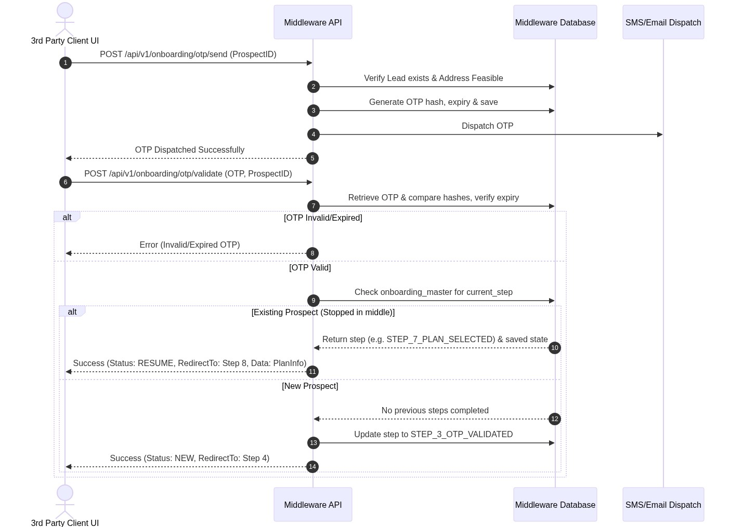

Editable Flow Chart / Message Sequence Table (Edit Directly inside MS Word):
No. | Sender Component | Receiver Component | Interaction / Message Description | Expected Response / Outcome
1 | 3rd Party Client UI | Middleware API | POST /otp/send (Prospect ID) | Initiates verification check.
2 | Middleware API | MySQL DB | Verify lead exists & is feasible? | Confirms active prospect.
3 | Middleware API | PostgreSQL DB | Generate & save hashed OTP + expiry | Persists verification record.
4 | Middleware API | SMS Service | Dispatch OTP request | Triggers SMS delivery.
5 | SMS Service | 3rd Party Client UI | Deliver 6-digit code via SMS | User receives code.
6 | 3rd Party Client UI | Middleware API | POST /otp/validate (OTP, Prospect ID) | Validates code.
7 | Middleware API | PostgreSQL DB | Retrieve OTP hash & check validation | Checks hash & expiry.
8 | Middleware API | PostgreSQL DB | Check master table current_step | Determines progress stage.
9 | Middleware API | 3rd Party Client UI | Return NEW (Redirect to Step 4) or RESUME (Redirect to stopped step + data) | Frontend loads target stage.

Step 9: Asynchronous HOBS / 6D Account Creation & Payment Link Generation
--- Flowchart/Sequence Diagram 2 ---
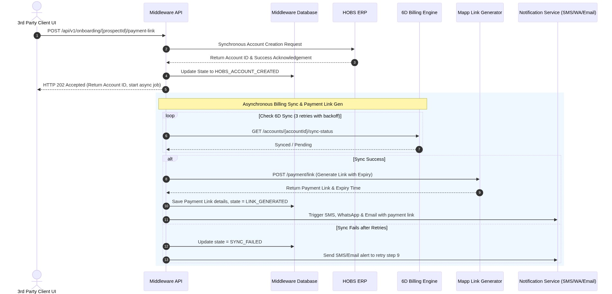

Editable Flow Chart / Message Sequence Table (Edit Directly inside MS Word):
No. | Trigger / Component | Target / Integration | Action Description | Execution Type | Exception Handling
1 | 3rd Party UI | Middleware API | POST /payment-link | Synchronous | Standard validation error return.
2 | Middleware API | HOBS ERP | Create Customer & Billing Account | Synchronous | Halt & fail request if HOBS is offline.
3 | Middleware API | PostgreSQL DB | Update master table to HOBS_CREATED | Synchronous | Saves database state.
4 | Middleware API | 3rd Party UI | Return HTTP 202 Accepted & Account IDs | Synchronous | Provides immediate response.
5 | Middleware API | 6D Billing Engine | Poll billing sync status (3 retries with 5s backoff) | Asynchronous | Log sync fail and trigger email alert to retry.
6 | Middleware API | Mapp API | POST /payment/link (Generate payment link) | Asynchronous | Lock progress and log failure.
7 | Middleware API | PostgreSQL DB | Save payment link, amount, and expiry | Asynchronous | Updates payment record.
8 | Middleware API | Notification Service | Trigger SMS, WA, Email with payment link | Asynchronous | Dispatches link to customer.

---

4. Implementation Details for Core Controls

A. Gatekeeping Interceptor (Flow Controller)
To enforce that a customer does not bypass any onboarding step, a custom AOP aspect is registered in the Spring Boot application:
@Aspect
@Component
public class OnboardingFlowAspect {
@Autowired
private OnboardingMasterRepository repository;
@Before("@annotation(requireStep)")
public void verifyStepGate(JoinPoint joinPoint, RequireStep requireStep) {
Object[] args = joinPoint.getArgs();
UUID prospectId = extractProspectId(args);
OnboardingMaster master = repository.findById(prospectId)
.orElseThrow(() -> new ProspectNotFoundException("Prospect ID invalid"));
StepEnum currentStep = StepEnum.valueOf(master.getCurrentStep());
StepEnum requiredPrerequisite = requireStep.value();
if (currentStep.ordinal() < requiredPrerequisite.ordinal()) {
throw new FlowViolationException(
"Flow violation: Required prerequisite is " + requiredPrerequisite.name()
+ ". Current stage is " + currentStep.name(),
currentStep
);
}
}
}

B. Column Encryption Converter (DPDP Compliance)
A Spring JPA Converter utilizes AES-256-GCM symmetric encryption for securing sensitive table attributes:
@Converter
public class PiiEncryptionConverter implements AttributeConverter<String, String> {
@Autowired
private EncryptionService encryptionService; // Resolved from Key Vault secret
@Override
public String convertToDatabaseColumn(String attribute) {
return (attribute == null) ? null : encryptionService.encrypt(attribute);
}
@Override
public String convertToEntityAttribute(String dbData) {
return (dbData == null) ? null : encryptionService.decrypt(dbData);
}
}
Applied to entity fields: Name, RMN, Email, Address, and Document numbers.

